Staron® Colors
Available in more than 80 colors, Staron® is grouped into seven categories characterized by the size and density of the particulate. Click on the icons to see the full range of color choices within each category.
Tempest Colors
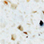 | 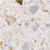 | 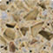 | 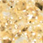 | 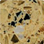 | 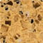 | 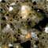 | 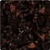
Horizon | Shell | Caraway | Rattan | Russet | Cinnamon | Milestone | Coffee Bean
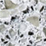 | 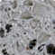 | 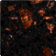 | 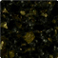 | 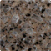 | 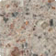 | 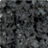 | 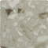
Sierra | Dapple | Radiance | Gold leaf | Whippoorwill | Glimmer | Zenith | Sandpiper
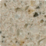 | 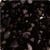 | 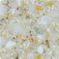 | 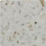
Sonoma | Starfire | Prairie | Confection

Designer Colors
Breccia - Staron's latest color category that features both a translucent and mosaic quality.
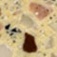 | 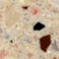 | 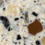
Breccia Bisque | Breccia Stoneware | Breccia RioGrande

Quarry - The Quarry color group features larger particulates with a rich, granite-like appeal.
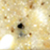 | 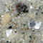 | 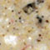 | 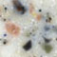 | 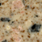 | 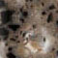 | 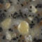 | 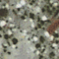
Quarry Esker | Quarry Butte | Quarry Riverbed | Quarry Arroyo | Quarry Mesa | Quarry Bluff | Quarry  Palisade | Quarry  Canyon
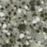
Quarry Mallard

Talus - Talus colors have a translucent quality, combining large crystal flecks with various particulate si
zes.
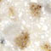 | 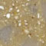
Talus Oyster | Talus Sandbar

Classic Colors
Solid - Our light, solid colors are ideal for countertops subjected to heavy use and require less frequent
maintenance. In addition to countertops, Staron Sinks and Bowls are available in three solid Col
ors: Bright White,Ivory and Pearl.
 |  | 
Bright White | Pearl | Ivory

Sanded - The colors in this group use small, sand-sized particles in varying degrees of depth and visibi
lity.
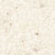 | 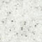 | 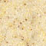 | 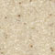 | 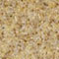 | 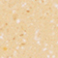 | 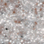 | 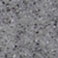
Sanded Cream | Sanded  White Pepper | Sanded Sahara | Sanded Gold Dust | Sanded  Vermillion | Sanded Ginger | Sanded Nebula | Sanded Grey
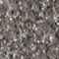 | 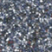 | 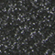 |  | 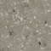 | 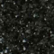 | 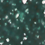
Sanded Mocha | Sanded Marine | Sanded  Dark Nebula | Sanded Onyx | Sanded Wheat | Sanded Noir | Sanded Leaf

Aspen - The colors in our Aspen group create a beautiful quartz-like appearance by combining small and
mid-sized particles in a bed of muted solid colors.
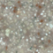 | 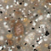 | 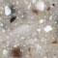 | 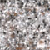 | 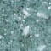 | 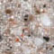 | 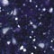 | 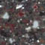
Aspen Jade | Aspen Brown | Aspen Pepper | Aspen Slate | Aspen Spruce | Aspen Amber | Aspen Sky | Aspen Dark
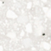 | 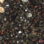
Aspen Snow | Aspen Mine

Pebble - Our selection of pebble colors combine large, more visible particulates in a bed of small and mi
d-sized particles to create a granite-like impression.
 | 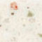 | 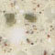 | 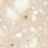 | 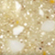 | 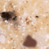 | 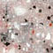 | 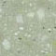
Pebble Frost | Pebble Beach | Pebble Caper | Pebble Saratoga | Pebble Gold | Pebble Maize | Pebble Rose | Pebble Aqua
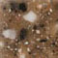 | 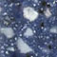 | 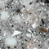 | 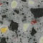 | 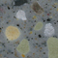 | 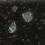 | 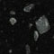 | 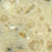
Pebble Copper | Pebble Blue | Pebble Grey | Pebble Shale | Pebble Castle | Pebble Sienna | Pebble Ebony | Pebble Seastar
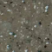 | 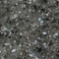
Pebble Fennel | Pebble Basalt

Encore recycled content series
Aspen Snow | Aspen Mine | Sanded Wheat | Sanded Noir | Pebble Seastar | Pebble Fennel | Pebble Basalt

